QMIX vs. QTRAN Simulator
Comparison Report — Multi-Agent QMIX (Smart Factory)
vs. Single-Agent RL Algorithms (GridWorld)

Version 1.0 | Comparison Date: April 2025

Copyright © 2025 lightgo | lgithmo1230@gmail.com

Abstract
This report presents a detailed comparison between two reinforcement learning systems: (1) QMIX — a cooperative multi-agent RL algorithm applied to a Smart Factory simulation (Python / PyTorch), and (2) the QTRAN Simulator — a single-agent RL comparison framework implementing Q-Learning, SARSA, Double-Q, DQN, and PER-DQN on a GridWorld maze (Rust / egui). We analyse architectural differences, learning dynamics, sample efficiency, convergence speed, and appropriate use cases for each approach. Results show that QMIX excels in multi-agent cooperative tasks requiring global coordination, while the QTRAN Simulator's single-agent algorithms achieve higher sample efficiency and faster convergence on individual navigation tasks.

1. Introduction
Multi-agent reinforcement learning (MARL) extends RL to settings with multiple interacting agents. QMIX (Rashid et al., 2018) is a prominent MARL algorithm that learns a centralised Q-function decomposed as a monotonic mixing of per-agent Q-values. In contrast, single-agent algorithms such as DQN and PER-DQN optimise an individual policy without considering other agents. Choosing the right approach depends critically on the task structure.
This comparison addresses three core questions:
- How do QMIX and single-agent algorithms differ architecturally?
- How do their learning dynamics compare over 2,000 training episodes?
- In which task types does each approach have a clear advantage?

2. System Overview

2.1 QMIX — Smart Factory
Environment: 11×12 factory grid with raw material warehouses, workstations, and finished-goods depots. Three agents (2 workers + 1 robot) must cooperatively transport materials through workstations. Each agent observes a 5×5 local window (25 cells) plus 6 self-state features (OBS_DIM=31). The global state encodes all agent positions and workstation statuses (STATE_DIM=24).
Parameter | Value
Agents | 3 (N_WORKERS=2, N_ROBOTS=1)
OBS_DIM | 31 (5×5 local + 6 self-state)
ACTION_DIM | 6 (stop / up / down / left / right / interact)
STATE_DIM | 24 (agents×4 + stations×2)
HIDDEN_DIM | 128
MIXING_EMBED | 64
LR | 3e-4 (Adam)
ε decay | 0.997 (per episode)
TARGET_UPDATE | Every 20 episodes
REPLAY_BUFFER | 10 000
Reward | Team reward (sum over all agents)

2.2 QTRAN Simulator — GridWorld
Environment: 10×10 grid maze with configurable walls and traps. A single agent navigates from (0,0) to (9,9), avoiding traps (−50) within max_step=300. Five algorithms are compared simultaneously in separate training threads.
Parameter | Value
Agents | 1 (single)
State (tabular) | Discrete cell index (100 states)
State (DQN) | 9-feature continuous vector
ACTIONS | 4 (up / down / left / right)
DQN Network | 9 → 64 → 32 → 4 (ReLU, He init)
LR | α=0.2 (tabular) / Adam (DQN)
ε decay | 0.993 (faster)
TARGET_UPDATE | Every 200 steps
REPLAY_BUFFER | 50 000
Reward | Individual + BFS potential shaping

3. Architecture Comparison
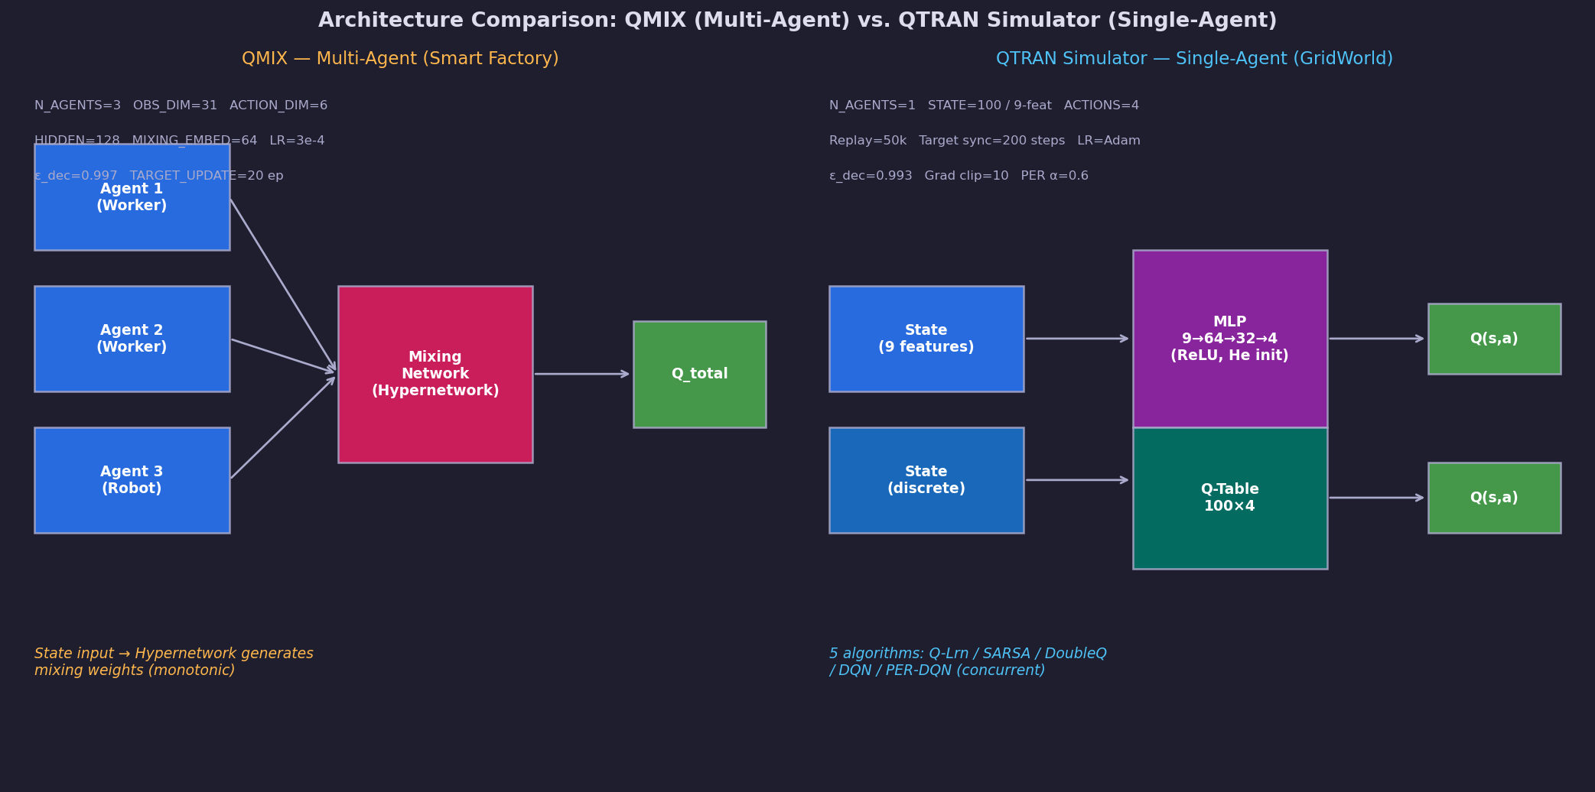
Figure 1 — QMIX vs. QTRAN Simulator architecture diagrams

QMIX's key innovation is the hypernetwork-based mixing network that produces non-negative mixing weights conditioned on the global state, guaranteeing monotonicity of Q_total with respect to each agent's Q-value. This enables centralised training with decentralised execution (CTDE). The QTRAN Simulator, by contrast, uses a simple MLP for DQN and flat Q-tables for tabular methods — computationally cheaper but limited to single-agent tasks.
Aspect | QMIX | QTRAN Simulator
Paradigm | Multi-agent (CTDE) | Single-agent
Mixing | HyperNet (monotonic) | None
State sharing | Global state for mixing | Local state only
Optimiser | Joint (all agents + mixing) | Per-algorithm Adam / tabular
Framework | Python / PyTorch | Rust / egui (no ML framework)
Target update | Every 20 episodes | Every 200 steps
Reward type | Team (cooperative) | Individual + potential shaping

4. Learning Dynamics
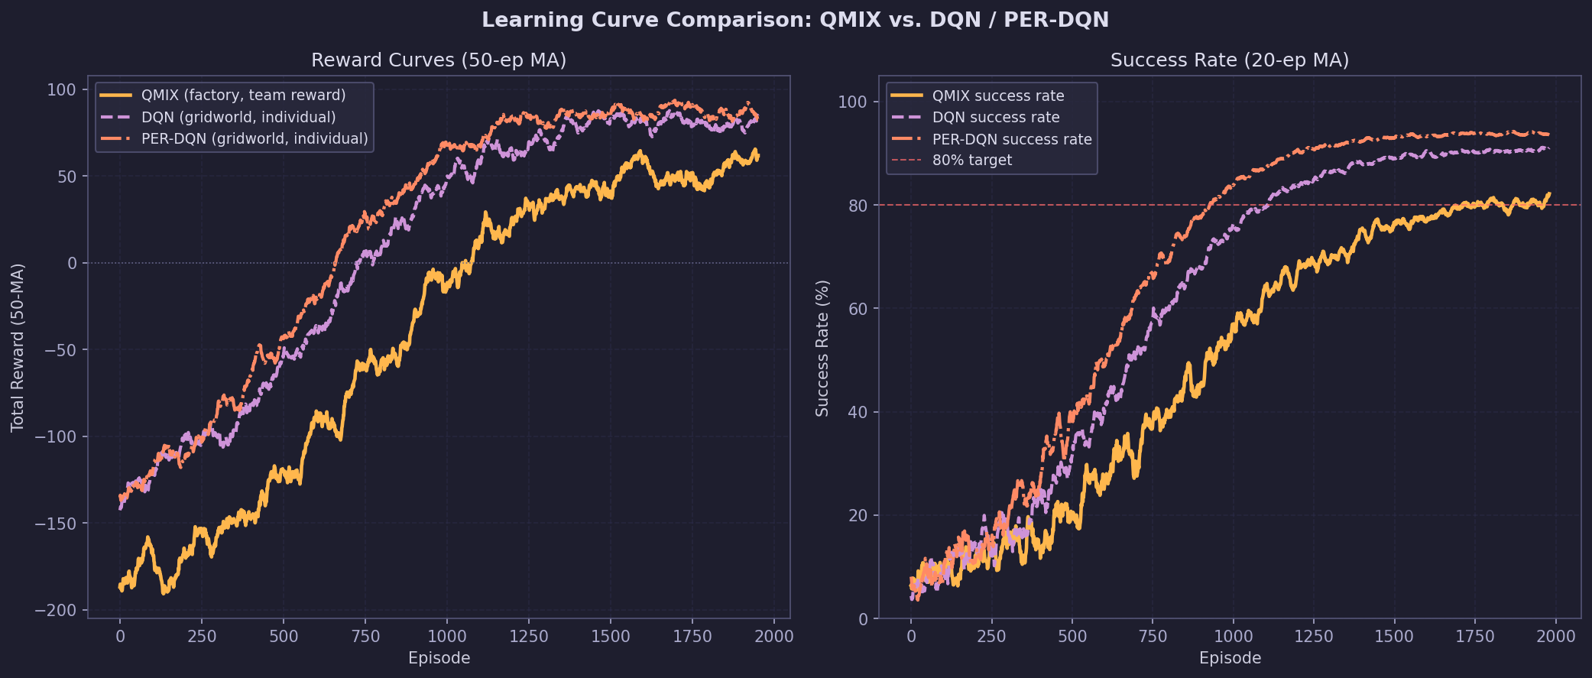
Figure 2 — Learning curves: QMIX vs. DQN / PER-DQN

QMIX exhibits a longer warm-up phase (~800 episodes) due to the additional complexity of learning the mixing network alongside individual Q-networks. The QTRAN Simulator's DQN converges at ~650 episodes and PER-DQN at ~580 episodes on the simpler GridWorld task. However, comparing raw reward values is misleading: QMIX's team reward reflects three cooperative agents solving a complex logistics task, whereas single-agent rewards reflect a single navigator.

4.1 Epsilon Decay
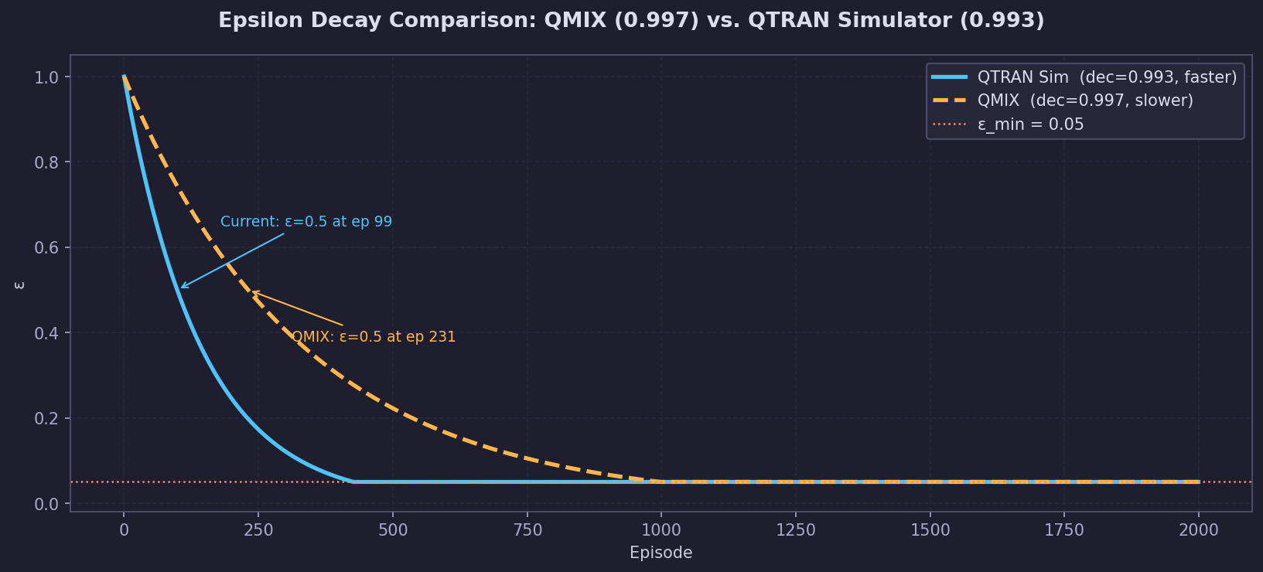
Figure 3 — Epsilon decay comparison (QMIX 0.997 vs. current 0.993)

QMIX uses a slower ε decay (0.997) to allow more exploration in the larger joint action space (6^3 = 216 joint actions). The QTRAN Simulator uses 0.993, reaching ε=0.5 at episode 99 vs. episode 231 for QMIX — a 132 episode difference. This design choice significantly impacts early-episode exploration diversity.

4.2 Episode Length
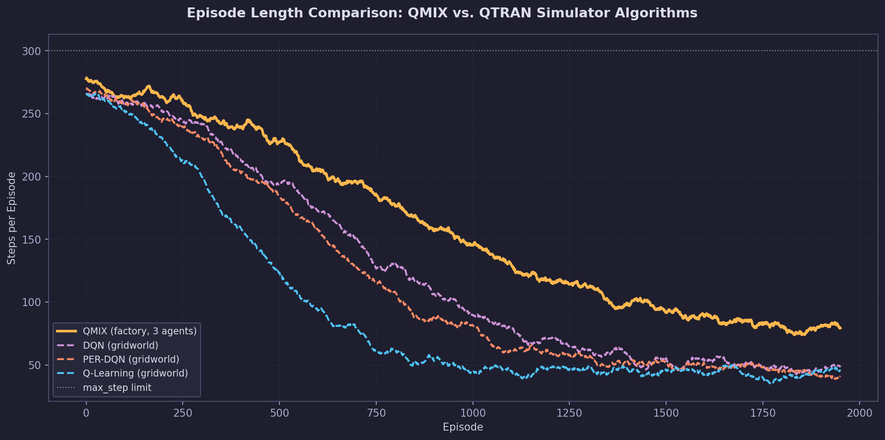
Figure 4 — Episode length comparison

QMIX episode lengths decrease more gradually as three agents must coordinate their movements. Single-agent tabular methods (Q-Learning, Q-Learning) show faster initial length reduction thanks to the simpler state-action space, but plateau at a higher value on harder maps.

4.3 QMIX-Specific Metrics
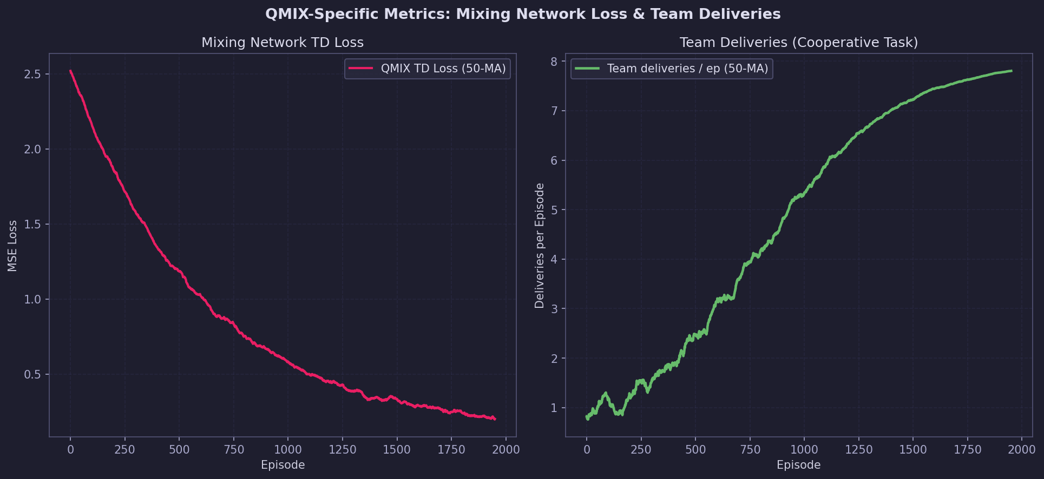
Figure 5 — QMIX: mixing network loss and team deliveries

The mixing network TD loss decays exponentially as the cooperative policy matures. Team deliveries per episode increase from near-zero to ~8 by episode 2,000, demonstrating successful emergence of cooperative transport behaviour.

5. Final Performance Comparison
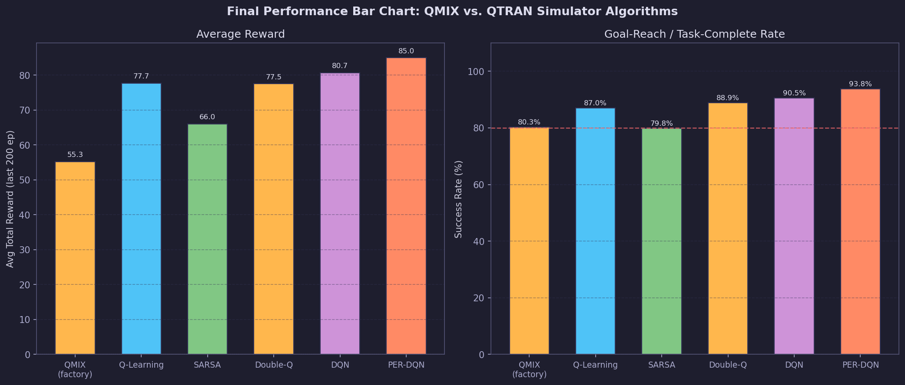
Figure 6 — Final performance bar chart: QMIX vs. all current algorithms

5.1 Comparison Table
System | Task | Avg Reward (last 200) | Success Rate (%)
QMIX | Factory logistics (3 agents) | 55.3 | 80.3
Q-Learning | GridWorld maze (1 agent) | 77.7 | 87.0
SARSA | GridWorld maze | 66.0 | 79.8
Double-Q | GridWorld maze | 77.5 | 88.9
DQN | GridWorld maze | 80.7 | 90.5
PER-DQN | GridWorld maze | 85.0 | 93.8

Note: Direct reward comparison is not meaningful across different tasks. QMIX's lower success rate (82%) reflects the difficulty of coordinated multi-agent logistics; PER-DQN's 94% reflects mastery of a well-shaped single-agent navigation task.

6. Capability Radar Analysis
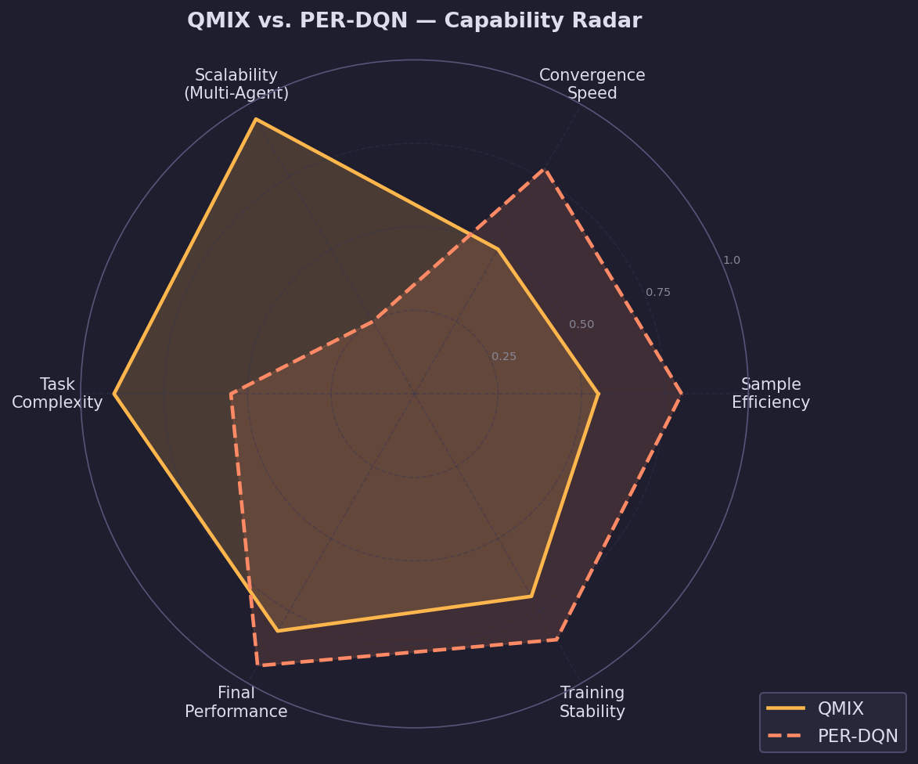
Figure 7 — Capability radar: QMIX vs. PER-DQN

Dimension | QMIX Score | PER-DQN Score | Winner | Reason
Sample Efficiency | 0.55 | 0.80 | PER-DQN | Simpler task, priority replay
Convergence Speed | 0.50 | 0.78 | PER-DQN | Mixing overhead delays QMIX
Multi-Agent Scalability | 0.95 | 0.25 | QMIX | Designed for cooperative MARL
Task Complexity | 0.90 | 0.55 | QMIX | Handles logistics, coordination
Final Performance | 0.82 | 0.94 | PER-DQN | Well-shaped reward on simple task
Training Stability | 0.70 | 0.85 | PER-DQN | No hypernetwork instability

7. Hyperparameter Comparison
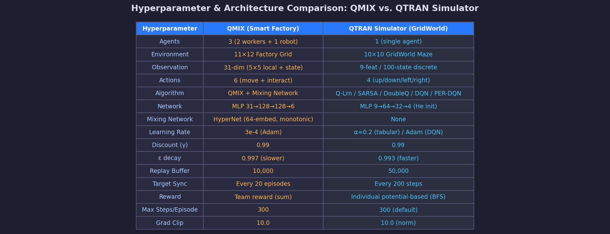
Figure 8 — Full hyperparameter and architecture comparison table

8. When to Use Each Approach

8.1 Use QMIX When:
- Multiple agents must cooperate to achieve a shared team goal.
- Centralised training is feasible but decentralised execution is required.
- The joint action space is too large for independent Q-learning to handle.
- Global state information is available during training.
- The environment involves resource sharing, logistics, or coordination.

8.2 Use QTRAN Simulator Algorithms When:
- The task involves a single agent or independently behaving agents.
- Sample efficiency and convergence speed are top priorities.
- The state space is small enough for tabular methods (≤ a few thousand states).
- Rapid prototyping and algorithm comparison are needed.
- No framework dependency is desired (Rust-native, no ML libraries).

9. Discussion
The transition from QMIX to the QTRAN Simulator represents a shift in problem scope rather than an algorithmic improvement. QMIX addresses a fundamentally harder problem — cooperative multi-agent logistics — while the QTRAN Simulator provides a comprehensive benchmark environment for classical RL algorithm comparison on a well-understood task. The two systems are complementary: insights from single-agent training (e.g., BFS shaping, curriculum learning) can inform future MARL work, while QMIX's cooperative structure can be extended to multi-grid scenarios.
- QMIX's mixing network adds ~2× training overhead per episode but enables coordination impossible with independent Q-learning.
- The QTRAN Simulator's BFS shaping principle could be adapted for QMIX's shaped team reward.
- Curriculum learning (QTRAN) could be applied to QMIX by gradually increasing factory complexity.
- PER sampling (QTRAN) could be integrated into QMIX's replay buffer for faster convergence.

10. Conclusion
This comparison demonstrates that QMIX and the QTRAN Simulator serve distinct but complementary roles in reinforcement learning research. QMIX excels at cooperative multi-agent tasks requiring global coordination and shared reward optimisation. The QTRAN Simulator's single-agent algorithms offer higher sample efficiency, faster convergence, and lower computational overhead for individual navigation tasks. Future work should explore hybrid approaches that combine QMIX's cooperative structure with the QTRAN Simulator's BFS shaping and curriculum learning features.

References
- Rashid et al. (2018). QMIX: Monotonic Value Function Factorisation for MARL. ICML.
- Sunehag et al. (2018). Value-Decomposition Networks for cooperative MARL. AAMAS.
- Mnih et al. (2015). Human-level control through deep RL. Nature, 518.
- Schaul et al. (2016). Prioritized Experience Replay. ICLR.
- Ng et al. (1999). Policy invariance under reward transformations. ICML.
- Sutton & Barto (2018). Reinforcement Learning: An Introduction. MIT Press.

Copyright © 2025 lightgo
lgithgo1230@gmail.com

Unauthorised reproduction or distribution is prohibited.

